

*IP Assignment 03*

***NAME = RAMEEZ BADRUDDIN KHWAJA***

***CMS-ID = 263-2023***

***COURSE = ADP-CIS***

***DEPARTMENT = COMPUTER SCIENCE***

***SEMESTER= 4***

***FACULTY = FEST***

***SUBJECT = Internet Programming***

***SUPERVISED BY = Miss Zaheen Fatima***

***Date Given: 20-12-24***

***Deadline = 30-12-24***

***Total Marks = 4***

**Question 1:** Write a program that displays output as shown in screenshot below. When you click on button

“Prepended text” then text “Prepended text.” added before Paragraphs. When you click on

button “Prepend list item” then text “Prepended item” added before List items. When you

click on button “This is for Append to paragraph text” then text “Prepended text.” added

after Paragraphs. When you click on button “This is for Append?

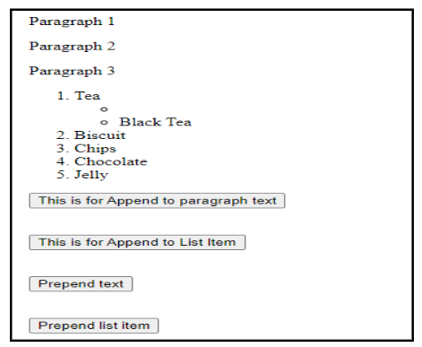

**Answer:**

<!DOCTYPE html>

<html>

<head>

<title>Text Manipulation</title>

<script src="jquery-3.7.1.min.js"></script>

<style>

.container {

width: 600px;

margin: 20px auto;

padding: 20px;

border: 1px solid #ccc;

}

.button-group {

margin-top: 20px;

}

button {

margin: 5px;

padding: 5px 10px;

}

.nested-list {

margin-left: 20px;

}

</style>

<script>

$(document).ready(function() {

// Prepend text to paragraphs

$('#prependText').click(function() {

$('#paragraphs p').each(function() {

$(this).prepend('Prepended text. ');

});

});

// Prepend text to list items

$('#prependListItem').click(function() {

$('#mainList > li').each(function() {

let currentText = $(this).clone() // Clone the element

.children() // Get all the child elements

.remove() // Remove all the children

.end() // Go back to selected element

.text() // Get the text content

.trim(); // Remove whitespace

$(this).contents().first().replaceWith('Prepended item ' + currentText);

});

});

// Append text to paragraphs

$('#appendParagraph').click(function() {

$('#paragraphs p').each(function() {

$(this).append(' Prepended text.');

});

});

// Append new item to list

$('#appendList').click(function() {

$('#mainList').append('<li>Nimco</li>');

});

});

</script>

</head>

<body>

<div class="container">

<!-- Paragraphs -->

<div id="paragraphs">

<p>Paragraph 1</p>

<p>Paragraph 2</p>

<p>Paragraph 3</p>

</div>

<!-- List -->

<ol id="mainList">

<li>Tea

<ul class="nested-list">

<li></li>

<li>Black Tea</li>

</ul>

</li>

<li>Biscuit</li>

<li>Chips</li>

<li>Chocolate</li>

<li>Jelly</li>

</ol>

<!-- Buttons -->

<div class="button-group">

<button id="appendParagraph">This is for Append to paragraph text</button>

<button id="appendList">This is for Append to List Item</button>

<button id="prependText">Prepend text</button>

<button id="prependListItem">Prepend list item</button>

</div>

</div>

</body>

</html>

**Output:**

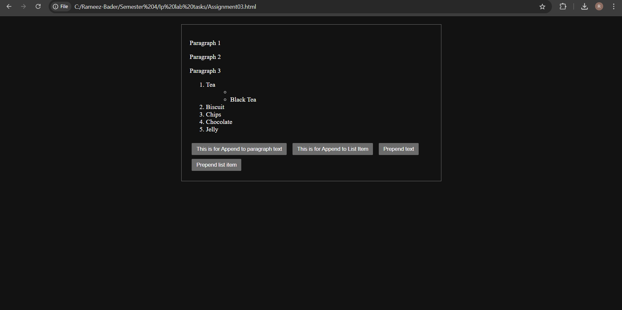

**Question 2:** Write program in jQuery that generates output as shown in the picture below:

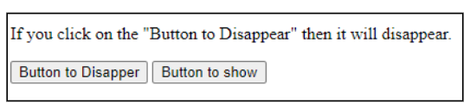

When user clicks on Button to Disappear then the paragraph “If you click on the &quot;Button to Disappear&quot;

then the paragraph will disappear with speed 2000. “If you click on the &quot;Button to show&quot; then the

paragraph show with speed 1000.

**Answer:**

<!DOCTYPE html>

<html>

<head>

<title>Button Hide/Show Demo</title>

<script src="jquery-3.7.1.min.js"></script>

<style>

.container {

width: 500px;

margin: 20px auto;

padding: 20px;

border: 1px solid #ccc;

}

button {

margin: 5px;

padding: 5px 10px;

}

#textToHide {

margin-bottom: 20px;

}

</style>

<script>

$(document).ready(function() {

// Handle disappear button click

$("#btnDisappear").click(function() {

$("#textToHide").fadeOut(2000); // 2000ms = 2 seconds

});

// Handle show button click

$("#btnShow").click(function() {

$("#textToHide").fadeIn(1000); // 1000ms = 1 second

});

});

</script>

</head>

<body>

<div class="container">

<p id="textToHide">If you click on the "Button to Disappear" then it will disappear.</p>

<button id="btnDisappear">Button to Disapper</button>

<button id="btnShow">Button to show</button>

</div>

</body>

</html>

**Output:**



